# **Be a Member of the Cooperative**

### Get More. Go Deeper. Support the Work.

Zoe's avatar

[Zoe](https://substack.com/@zoeffc)

Mar 05, 2025

1

Share

Hey there,

I created *The Femme Futures Cooperative* because it is hard to navigate the corporate world, and because I know we’re stronger together. Navigating the Corporate World as a woman isn’t just about climbing the ladder—it’s about challenging the system, finding our people, and rewriting the rules in our favor.

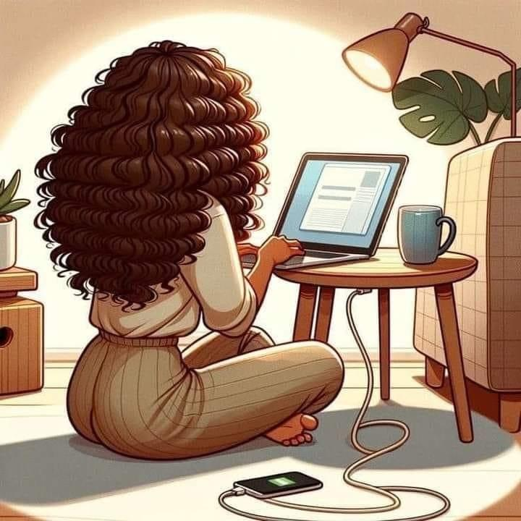

artist unknown

This isn’t just a newsletter; it’s a community. That has always been my hope for this space. Last June, when I wrote my first newsletter that went to exactly three people, I was needing a group of like-minded people to talk to. It felt like I would be more able to show up to work everyday and face the challenges that I was facing if I knew on some level that I wasn’t alone. Now there are over 50 of you who have opted to be a part of this dream.

Now, I’m inviting you to take it a step further. By pledging your support as a paid subscriber.

I get that there are barriers—whether it’s financial constraints or hesitation about using Substack. Here’s the deal: I can’t make this project financially viable unless I am able to generate a list of people who click that “Pledge your support” button. By clicking that button you are simply saying that you will *consider* supporting Femme Futures should I choose to monetize it.

My plan at this point is to never take away what you have already been getting. Eventually, paid subscribers will simply be able to access more from me like:

* Exclusive content that dives deeper into strategies, personal stories, and behind-the-scenes perspectives.
* Access to a closed group chat where we can connect, vent, and strategize together.
* The satisfaction of directly supporting my work and ensuring it continues to grow.
* First dibs on new projects, special updates, and upcoming changes.

If this space has resonated with you, if you believe in the power of collective action in corporate spaces, your support will make all the difference.

Ready to help build the future of *The Femme Futures Cooperative*?

Subscribed

Thank you all for your support of me and this project for these rocky first stages. I cannot promise a decrease in rockiness, but I can promise to keep trying.

All my best and I will talk to you again on Friday.

Cheers,

Zoe